Mina Michael Nashed

DPS 924 – Final Project

Date Submitted: Dec 15, 2017

ASign

Final Report

**Essential/Core Features**

* Create a scheduled upcoming assignment – HALF COMPLETE
* Create a group for an upcoming group assignment – NOT COMPLETE
* Chat between members in a group assignment – NOT COMPLETE
* Sign-In and Registration functionality - COMPLETE
* Add/Remove a member from an existing group – NOT COMPLETE

**Reasons**

Out of the tasks I set out to do I completed the log in and register feature fully. I came very close to completing a scheduled list of upcoming assignment and if completed I would have been able to complete the rest of the tasks minus the group chat very easily. Due to time constraints and learning certain material very late in the semester on top off other course commitments I wasn’t able to complete a lot of the features.

**Screenshots of Final Product**

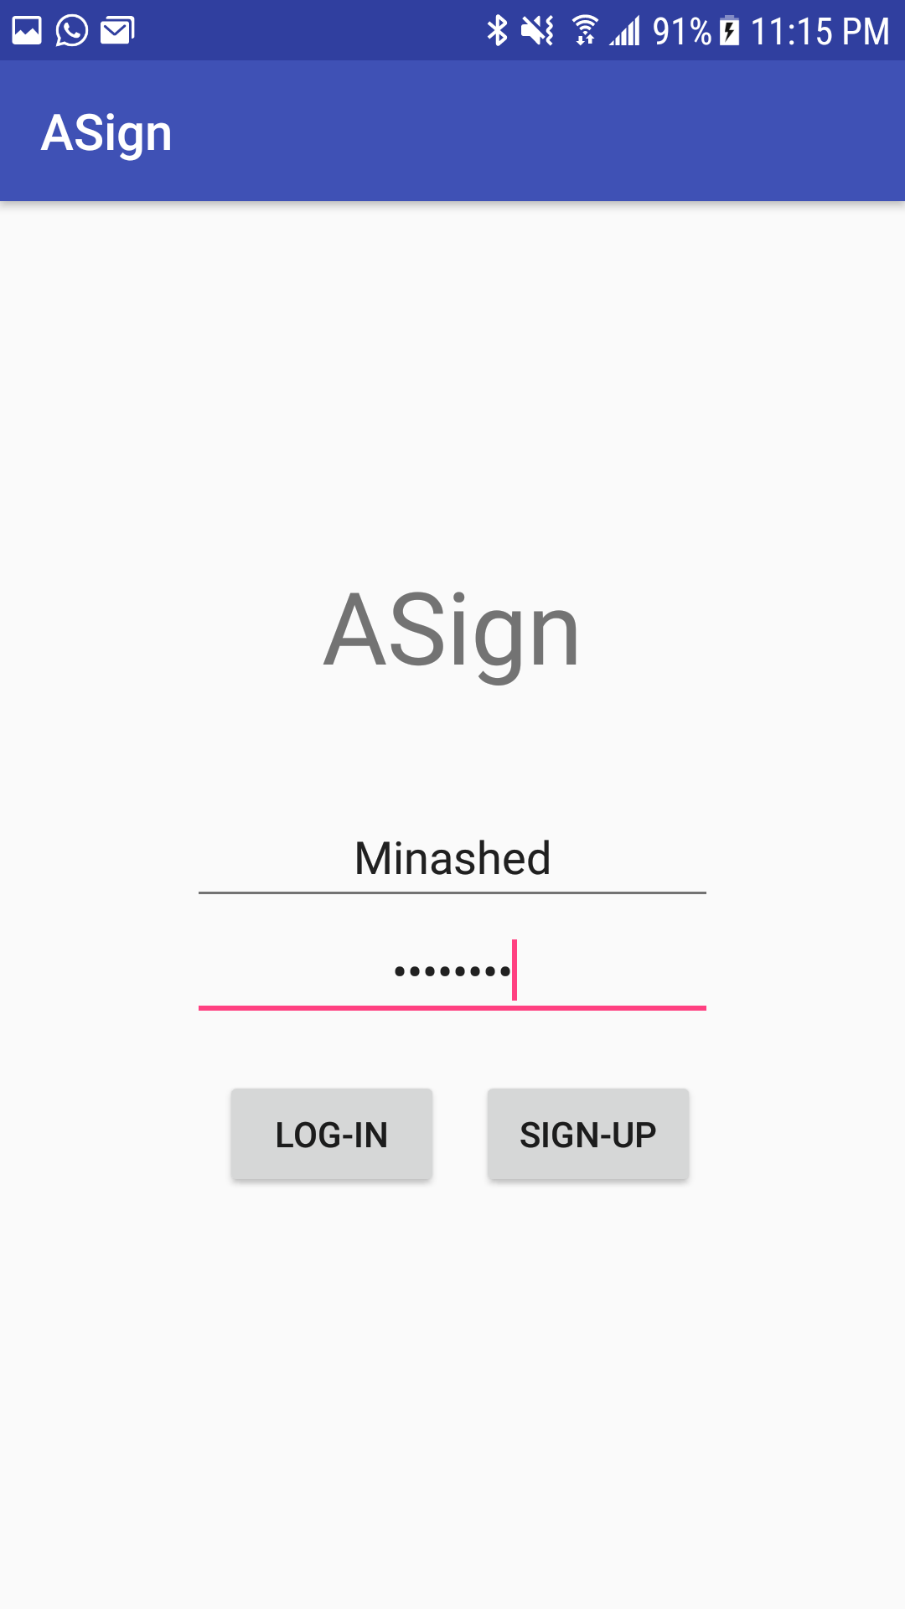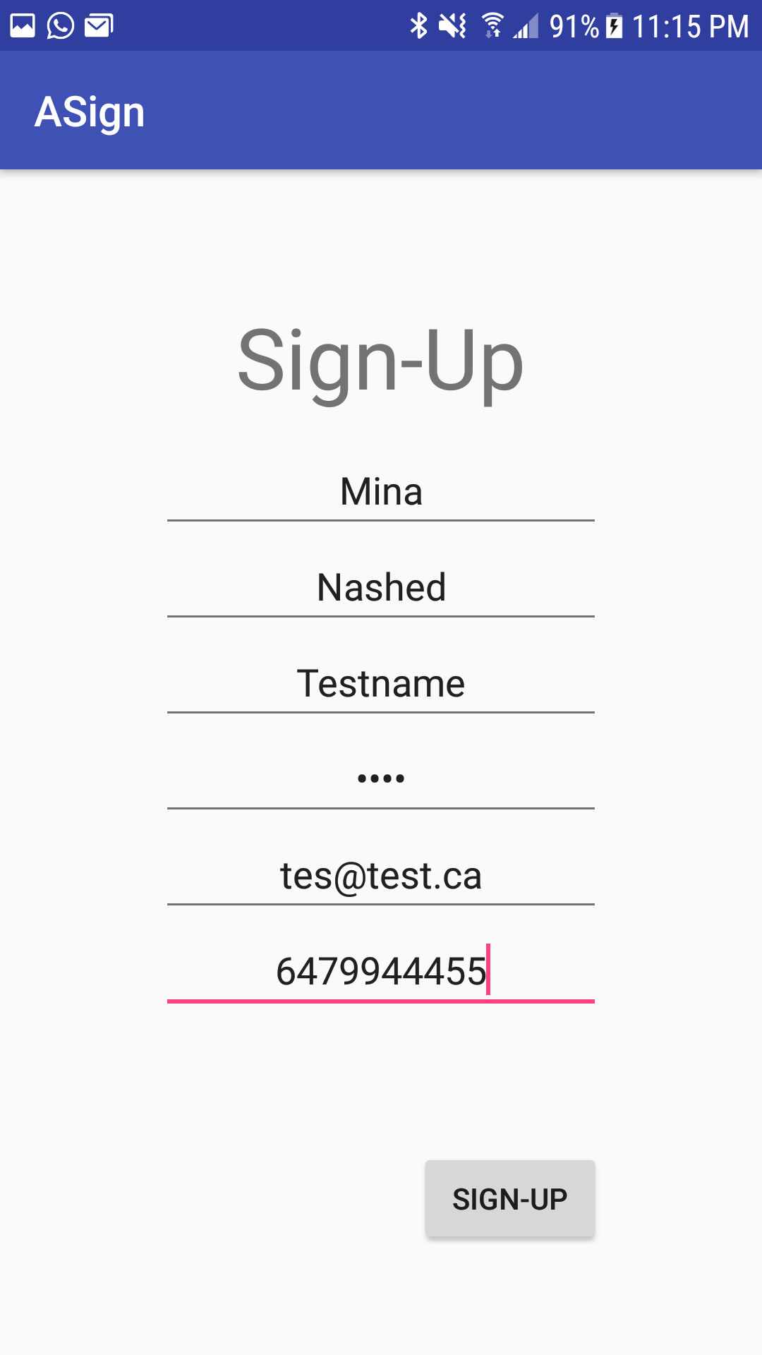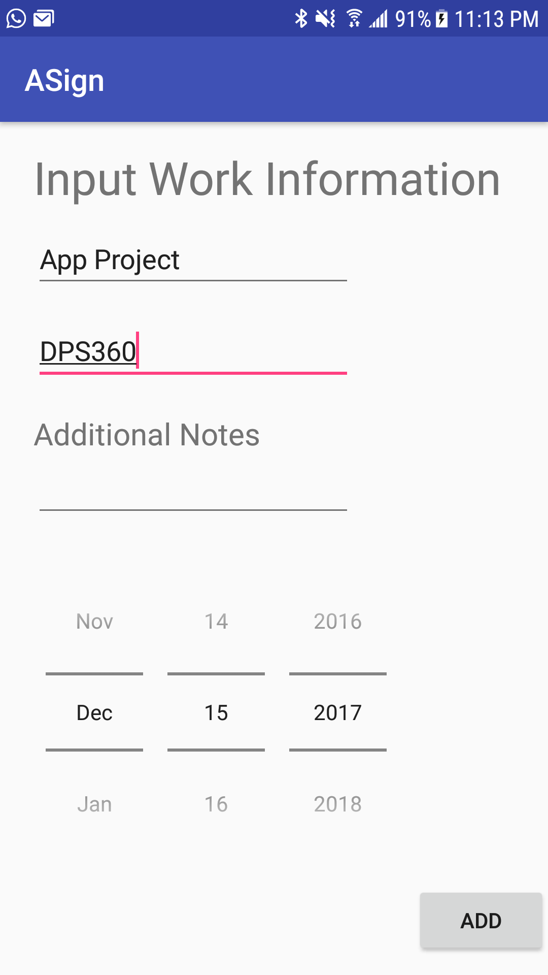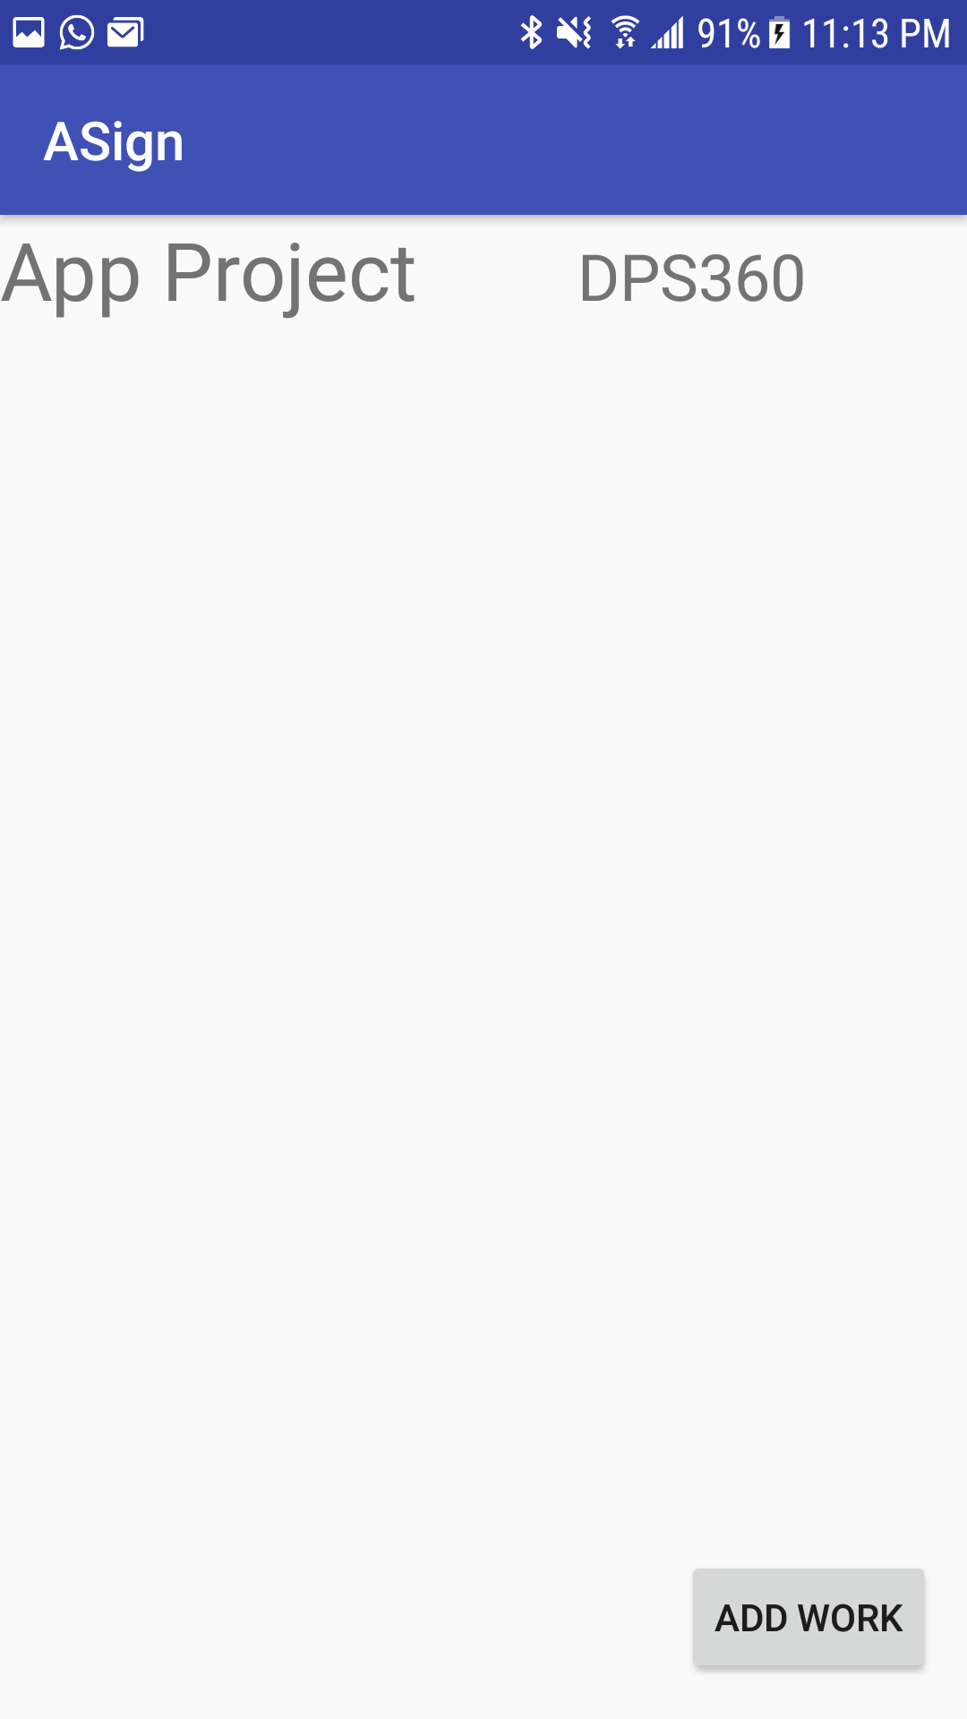

**Addition Notes**

* The database provide that I used closes service to my database around 10pm everyday so logging in/registering after a certain time won’t work due to the db being closed(since free).
* I left all the code I used to try to get the homework list working. Including attempts at persistent data, SQLite, and arrayadaptors.
* Added PHP used to communicate to DB.